**FOR IMMEDIATE RELEASE**

**MEDIA CONTACTS :**

**Adaora Onyebeke**

[adaora@philharmonicsociety.org](mailto:adaora@philharmonicsociety.org)

**Marie-Songco Torres**

[marie@philharmonicsociety.org](mailto:marie@philharmonicsociety.org)

Photo: Musacchio & Ianniello

**ITZHAK PERLMAN BRINGS THE JOYFUL SOUNDS OF KLEZMER MUSIC TO LIFE WITH *IN THE FIDDLER’S HOUSE* LIVE IN CONCERT**

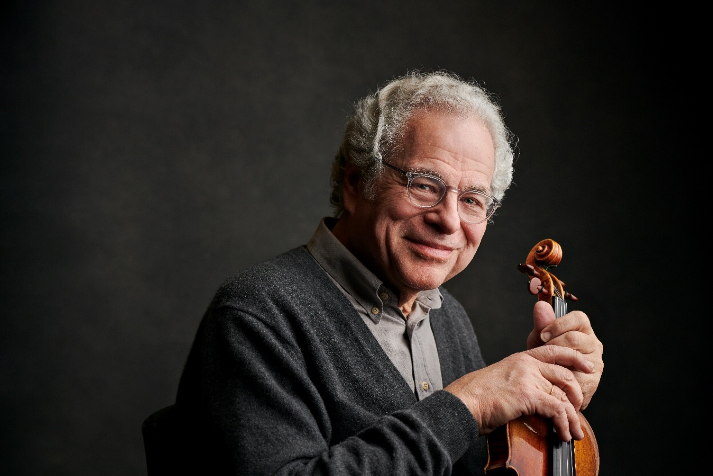

Photo: Masterclass.com

Photo: Mark Allan

**(IRVINE, CA, NOVEMBER 26, 2024)**— The Philharmonic Society of Orange County presents world-renowned violinist Itzhak Perlman as he brings the sounds of klezmer music to life with *In the Fiddler’s House* alongside an all-star ensemble on Tuesday, January 21, 2025, at 8 p.m. at the Renée and Henry Segerstrom Concert Hall. A pre-concert lecture with KUSC’s Brian Lauritzen will begin at 7pm.

This concert is part of the Eclectic Orange Series sponsored by Jelinek Family Trust and the Henry T. and Elizabeth Segerstrom Foundation Select Series.   
A major presence in the performing arts on television, Itzhak Perlman has been honored with four Emmy Awards.His third Emmy Award recognized his dedication to klezmer music, as profiled in the 1995 PBS television special ***In the Fiddler’s House***, which was filmed in Poland and featured him performing with four of the world’s finest klezmer bands. Perlman returns to this project, offering the opportunity to witness not only his masterful technique and remarkable artistry, but also “to see and hear a gifted musician experiencing the pleasure of getting in contact with his roots” (*Los Angeles Times*). In the 2024/25 season, Perlman celebrates the 30th anniversary of this iconic program with performances across the country alongside today’s klezmer stars including **Hankus Netsky, Andy Statman**, **Michael Alpert**, **Lorin Sklamberg**, **Judy Bressler**, **Frank London** and members of the **Klezmer Conservatory Band**.

Undeniably the reigning virtuoso of the violin, **Itzhak Perlman** enjoys superstar status rarely afforded a classical musician. Beloved for his charm and humanity as well as his talent, he is treasured by audiences throughout the world who respond not only to his remarkable artistry, but also to his irrepressible joy for making music.

Having performed with every major orchestra and at concert halls around the globe, Perlman has been honored with 16 GRAMMY® Awards, a Kennedy Center Honor, a Grammy Lifetime Achievement Award, and a Genesis Prize. Perlman has received multiple distinctions from U.S. Presidents over the years: A Presidential Medal of Freedom, the Nation’s highest civilian honor, by President Obama in 2015; a Kennedy Center Honor in 2003, a National Medal of Arts by President Clinton in 2000; and a Medal of Liberty by President Reagan in 1986.

Mr. Perlman has performed multiple times at the White House, and for Her Majesty The Queen and His Royal Highness The Duke of Edinburgh. In 2009, he was honored to take part in the Inauguration of President Obama, premiering a piece written for the occasion by John Williams alongside cellist Yo-Yo Ma, clarinetist Anthony McGill and pianist Gabriela Montero, for an audience of nearly 40 million television viewers in the United States and millions more throughout the world.

Renée and Henry Segerstrom Concert Hall is located at 615 Town Center Drive, Costa Mesa, CA 92626. Ticket prices start at $51 and are available at the Philharmonic Society box office at (949) 553-2422, ext. 1 or online at [www.philharmonicsociety.org](http://www.philharmonicsociety.org).

**ABOUT THE PHILHARMONIC SOCIETY:**

Founded in 1954 as Orange County’s first music organization, the Philharmonic Society of Orange County presents national and international performances of the highest quality and provides dynamic and innovative music education programs for individuals of all ages to enhance the lives of Orange County audiences through music.

Since its inception, the Philharmonic Society has evolved and grown with the county’s changing landscape, presenting artists and orchestras who set the standard for artistic achievement from Itzhak Perlman, Gustavo Dudamel, Yo-Yo Ma, and Renée Fleming to the Berlin Philharmonic, Vienna Philharmonic, Chicago Symphony Orchestra, and many others. In addition, the Philharmonic Society celebrates multi-disciplinary performances under its Eclectic Orange brand and embraces music from a wide range of countries with its World Music performances. Its celebrated concerts introduce children to classical music with creative and inspiring performances, instilling music appreciation for future generations.

The Philharmonic Society’s nationally recognized Youth Music Education Programs, offered free of charge, engage more than 100,000 students annually through curriculum-based music education programs that aim to inspire, expand imaginations, and encourage learning at all levels. These programs are made possible by the Committees of the Philharmonic Society comprised of 500 volunteer members who provide more than 90,000 hours of in-kind service each year. As a key youth program, the exceptional Orange County Youth Symphony and String Ensemble provide top-tier training to the area’s most talented young musicians through multi-level ensemble instruction, leadership training, touring opportunities, challenging professional repertoire, and performances in world-class venues. The Philharmonic Society also promotes life-long learning by connecting with colleges and universities to conduct masterclasses and workshops and providing pre-concert lectures to introduce audiences to program selections.

**MEDIA CONTACTS :**

**MEDIA CONTACTS :**

**Adaora Onyebeke**

[adaora@philharmonicsociety.org](mailto:adaora@philharmonicsociety.org)

**Marie-Songco Torres**

[marie@philharmonicsociety.org](mailto:marie@philharmonicsociety.org)

**WHAT:** Itzhak Perlman

"In the Fiddler’s House"

**Itzhak Perlman,** Violin

**Hankus Netsky**, Music Director, Arranger, Saxophone, Piano

**Andy Statman**, Clarinet, Mandolin

**Michael Alpert**, Vocals, Guitar, Accordion, Violin

**Lorin Sklamberg**, Vocals, Accordion

**Judy Bressler**, Vocals, Percussion

**Frank London**, Trumpet

**Klezmer Conservatory Band**

**Ilene Stahl**, Clarinet

**Mark** **Berney**, Trumpet

**Mark Hamilton**, Trombone

**James Guttmann**, Bass

**Grantley Smith**, Drums

**Pete Rushefsky**, Tsimbl

**WHEN:** Tuesday, January 21, 2025, 8pm

**PROGRAM:** "In the Fiddler’s House"

Pre-concert lecture by KUSC’s Brian Lauritzen, 7pm

**WHERE:** Renée & Henry Segerstrom Concert Hall, Segerstrom Center for the Arts

615 Town Center Drive, Costa Mesa, CA 92626

**TICKETS** Ticket prices start at $51.

Call for pricing and availability.

**AND**

Available at the Philharmonic Society box office (949) 553-2422

**INFORMATION:** or online at www.philharmonicsociety.org